ESAB BUDDY TIG 160 - TIG ( and MMA) WELDER – GETTING STARTED
mattlear@btinternet.com
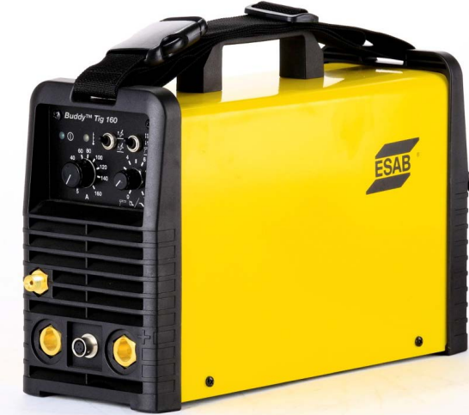
Manual
http://pdfmanuals.esab.com/private/Library/InstructionManuals/0463%20267%20001%20GB.pdf

To start welding on 2mm aluminium suggested settings
Argon or Argon / CO2 Gas flow 20psi / 15cfh
Tungsten (ceriated) electrode 2.4mm dia
Filler rod 2.4mm dia
Switch DOWN for
HF Start
(high frequency)

Switch DOWN for
2-STROKE control mode

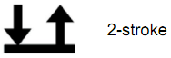
Switch DOWN for 2-STROKE control using the trigger switch 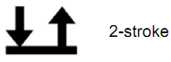

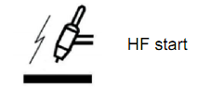
Around 80 amps

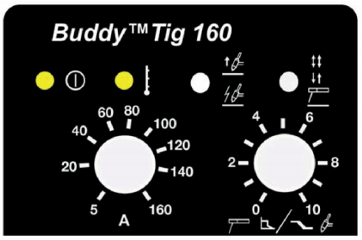

Slope Down set to 3 to minimise craters

Complete risk assessment for MMA

Calculating the settings for materials and thicknesses are not provided by ESAB. Try the following https://www.millerwelds.com/resources/weld-setting-calculators/tig-welding-calculator

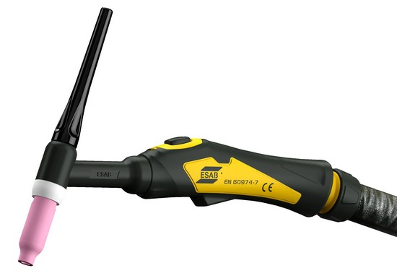

TRIGGER SWITCH

GAS VALVE (fitted on some models)

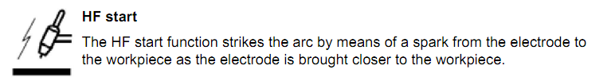
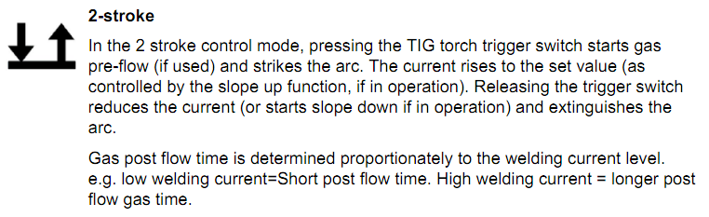
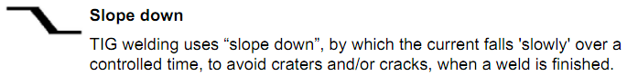

TIG FILLER RODS FOR A RANGE OF MATERIALS

http://www.esab.co.uk/gb/en/products/index.cfm?fuseaction=home.productsbycategory&catId=55

TUNGSTEN ELECTRODES – RANGE

http://www.esab.co.uk/gb/en/products/index.cfm?fuseaction=home.product&productCode=450506&tab=4

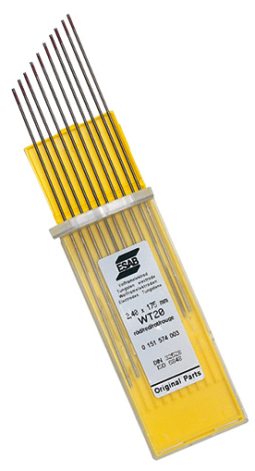
This is a high-quality range of tungsten electrodes available in ceriated, pure and lanthanated (Gold Plus) versions. ESAB tungsten electrodes have excellent welding and ignition properties. They are delivered in plastic boxes, each containing ten electrodes. The standard electrodes are 175 mm long, the Eco range is 150 mm long.
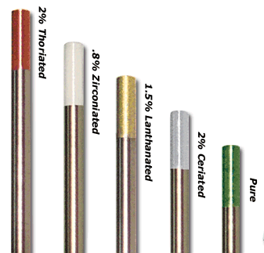

TUNGTEN ELECTRODES
COLOUR CODE

2% CERIATED (Grey) is one of the most used rods for both steels (DC) and aluminium alloys(AC)

IN PRACTICE KEEP THE TIP OF THE ELECTRODE THE SAME DISTANCE FROM THE WORKPIECE 1 to 1.5 times DIAMETER OF THE ELECTRODE BEFORE ACTIVATING THE TRIGGER SWITCH

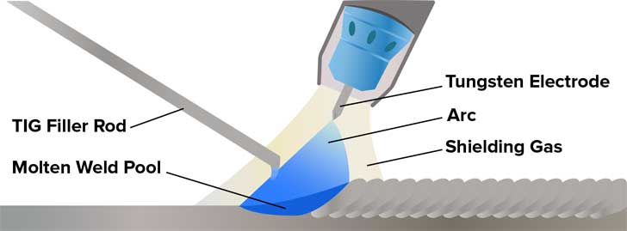

KEEP THE TUNGSTEN ELECTRODE POINT THE CORRECT SHAPE BY GRINDING
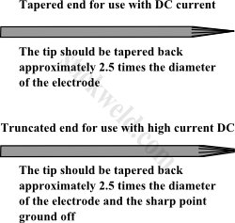
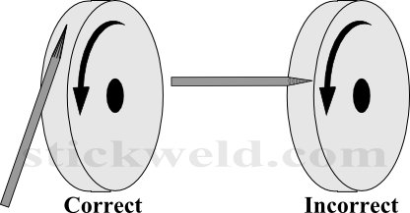

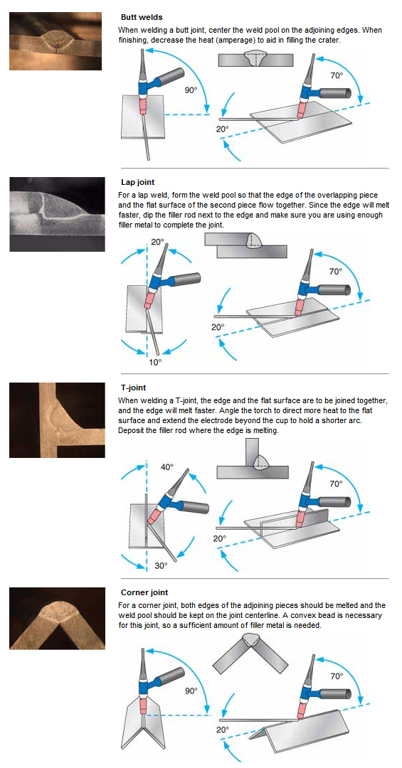
How do I position my TIG torch for different types of welds?
https://www.wellyweld.com/tech-tips.aspx

