ESAB CADDY C160i – MIG WELDER – GETTING STARTED
mattlear@btinternet.com
HANDBOOK http://www.esab.com/gb/en/support/upload/Caddy-Mig-C160i-2.pdf
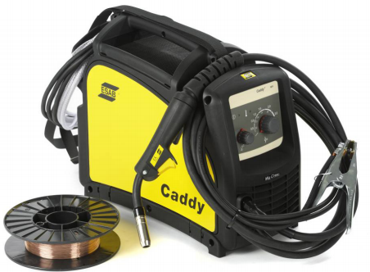
Check that the earth clamp is making good electrical contact with the metal by ensuring the clamp inner faces, the welding bench and metal are cleaned and free from oil, dirt etc. which will act as an insulator and prevent the arc striking properly

MIG Torch + Positive
Return lead (earth) - Negative

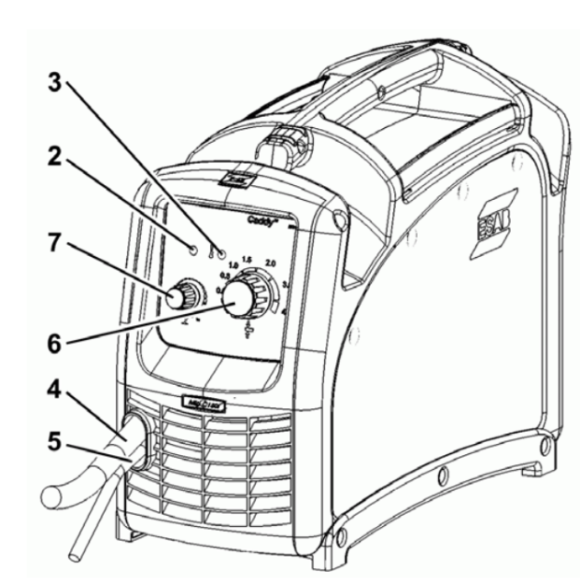

6 Control knob for setting best weld for material thickness - from 0.1mm to 4.0mm maximum, thicker material probably will not weld satisfactorily. (may also be marked in wire gauge 0.2 – 16.0 ga )

The Amps are automatically controlled from between 30 – 160 A

It also automatically adjusts and controls the wire feed at the optimum speed
7 Control knob for arc length correction - enabling fine adjustment of voltage for ‘hotter’ or ‘cooler’ welding, wider or narrower weld bead as well as the depth of penetration of the weld into the metal
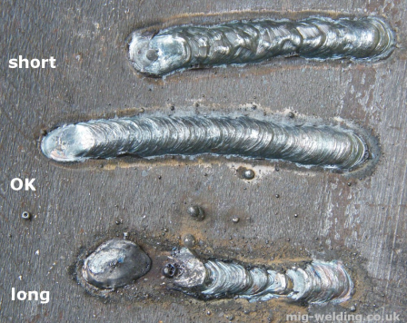
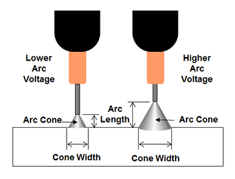

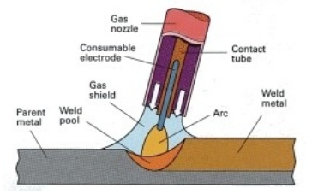
INERT GAS FLOW (Argon +CO2) must be delivered to the shroud (gas nozzle) at the correct rate to ensure the welded joint is protected by the gas envelope preventing oxidisation and slag formation and poor weld quality.

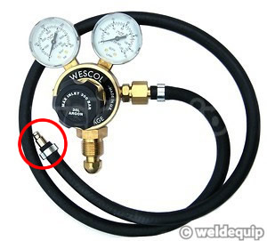
Check the regulator pressure in the cylinder and the gas output being delivered to the shroud.

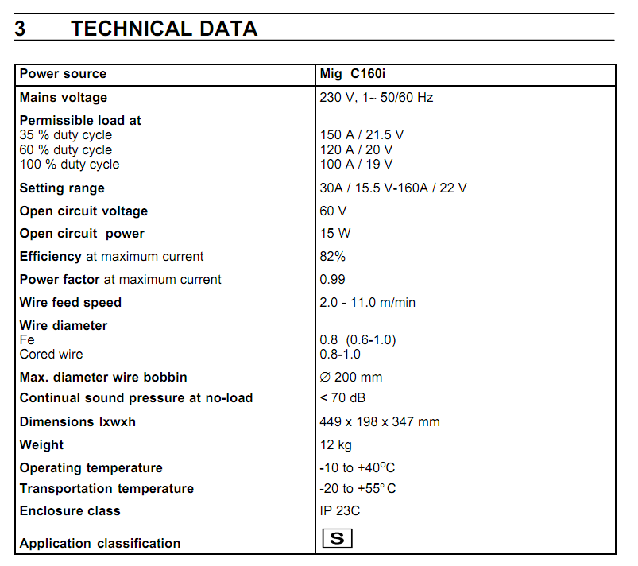

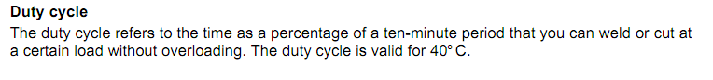

GENERIC MIG WELDING TUTORIAL
www.mig-welding.co.uk/tutorial.htm

ESAB DEMO HANDBOOK
https://www.google.co.uk/search?q=ESAB+Demo+handbook+C160i&rlz=1C1ASRM_enGB608GB609&oq=ESAB+Demo+handbook+C160i&aqs=chrome..69i57.13424j0j7&sourceid=chrome&ie=UTF-8

