Qualifying Welding Procedure

Preparation and Cleaning: Wire brushing
Metal: Stainless steel 316
Position: horizontal

Manufacture:
Location: Workshop
Welding Process: Arc
Joint type: Double sided T joint.
Arc example
Arc example
Weld Procedure Number

Process | Run | Electrode type | Electrode size | Voltage V | Current A | Type of current/ polarity | Travel speed | Metal thickness
Arc | 1,2 | Nicrex E316L | 2.5 mm | N/A | 85 | DC | N/A | Apply to metal thickness

Welding procedure:
Clean metal with wire brush or grinder
Clamp the work pieces into position on the work bench
Securely place the electrode in the electrode holder
Set the correct settings on the arc welder
Weld the double sided T joint
Turn the arc welder off
Leave the weld to cool before un- clamping.

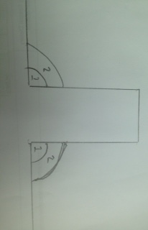

This is a drawing of the double sided T joint. The weld worked however it was not as strong as I would have liked. This could be because the first layer was not as deep as it could have been. It also could be because there were only two layers. Next time I do a double sided T joint I will make sure to do three layers.
I did an experiment weld after this on was performed and found that make sure that the first weld was right in the join and to do three layers. This greatly improved the strength of the T joint.

