Qualifying Welding Procedure

Preparation and Cleaning: Wet and dry paper.
Metal: 6 X 50 mild steel cold rolled flat bar
Position: vertical

Manufacture:
Location: Workshop
Welding Process: Manual MIG
Joint type: Single sided butt joint.
MIG example
MIG example
Weld Procedure Number

Process | Run | Size of wire | Current A | Voltage V | Type of current/ polarity | Wire feed speed | Travel speed | Metal thickness
MIG | 1, 2, 3 | 0.8 mm  1.2 mm | 100  160 | N/A | DC | N/A | N/A | 6mm
Welding procedure:
Use a wire brush or grinder to clean down bare metal.
Clamp the work pieces into position onto the work bench.
Set gas flow and current on the MIG welding.
Weld the single sided butt weld with three runs. Run 1 should be done with the thinner filler material. Run 2 and 3 should be done with the thicker filler material.
Turn the gas and MIG welder off
Leave the weld to cool before unclamping
Make sure to de- grease the weld after it has cold before the metal is panted of galvanised.

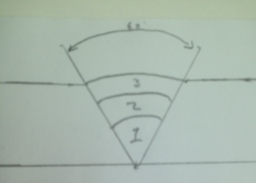

The weld was done with a MIG welder to create a single sided butt joint. This weld went well. The weld when finished was strong. To improve the weld I would decrease the voltage I was using to get a bit less of a weld pool.
I have decreased the voltage by a couple of volts and weld pool decreased and the second weld was neater than the first weld.
Another problem was the gas flow rate. When I was doing the welding I had to experiment on spare bits of metal to determine the best gas flow rate. It would’ve been better to of had a way to measure the correct gas flow rate but we don’t have the facilities to do this.

