BTEC Assignment Brief
Qualification |  | Pearson BTEC Level 3 National Extended Diploma in Engineering
Unit number and title |  | Unit 41: Manufacturing Secondary Machining Processes
Learning aim(s) (For NQF only) |  | A: Examine the technology and characteristics of secondary machining processes that are widely used in industry
Assignment title |  | 1. Secondary Machining Processes
Assessor |  | R.Smith
Issue date
Hand in deadline
Vocational Scenario or Context |  | You are working as a final year apprentice in the machine shop of a medium sized engineering company. Your supervisor is pleased with your work and your ability to operate machinery to carry out secondary machining processes.  Based on your practical skills, your supervisor would like you to produce a report that investigates the technology of secondary machining processes that are used in industry, as he needs some information that may be used in purchasing decisions. Your supervisor wants you to explore both traditional and specialist secondary machining processes, and the sustainability characteristics of each.
Task 1 |  | You have been asked to produce a written report that investigates three different traditional secondary machining processes and three different specialist secondary machining processes.  To do this:  Your tutor will provide you with a range of component drawings (and ideally physical examples) along with their specifications. You will use these examples to provide information and case study material for your report.  Research and produce a report that:  - investigates three different specialist secondary machining processes  (centre lathe, milling and pillar drill)  - investigates three different specialist machining processes  (electro-discharge, broaching, honing/lapping, presswork)  c) considers sustainability (energy consumption, disposal of fluids and waste material) issues for all of the six secondary machining processes chosen.  Your report should include:  - information and case studies related to three different traditional secondary machining processes that have been used in the production of the components provided to you by your tutor, including how they produce different features as well as particular reference to accuracy (e.g. tolerances), batch sizes and sustainable manufacturing,  - information and case studies related to three different specialist secondary machining processes that have been used in the production of the components provided to you by your tutor, including how they produce different features as well as particular reference to accuracy (e.g. tolerances), batch sizes and sustainable manufacturing; and  - an evaluation that compares the traditional and specialist secondary machining processes (from above) and why particular processes (rather than others) were chosen to produce the components provided to you by your tutor, with particular reference to accuracy (e.g. tolerances), batch sizes, and sustainability issues related to manufacturing.
Checklist of evidence required |  | A report focusing on three different traditional processes and an analysis of research case studies on three different specialist processes. Your report can be presented as posters as well as written case studies with diagrams and annotated notes.
Criteria covered by this task:
Unit/Criteria reference | To achieve the criteria you must show that you are able to:
41/A.D1 | Evaluate, using language that is technically correct and of a high standard, the use of contrasting traditional and specialist secondary machining processes to sustainably manufacture components in different batch sizes.
41/A.M1 | Analyse how different traditional and specialist secondary machining processes are used to sustainably manufacture different features on components to the intended accuracy.
41/A.P1 | Explain how different traditional and specialist secondary machining processes are used to manufacture different features on components.
Sources of information to support you with this Assignment |  | Websites  www.hse.gov.uk/work-equipment-machinery/standard.htm
Other assessment materials attached to this Assignment Brief

Item 1:
Exhaust clamping plate two view drawing.

Batch sizes required:
1 off
250 pieces
2500 pieces

Material: Mild steel 304
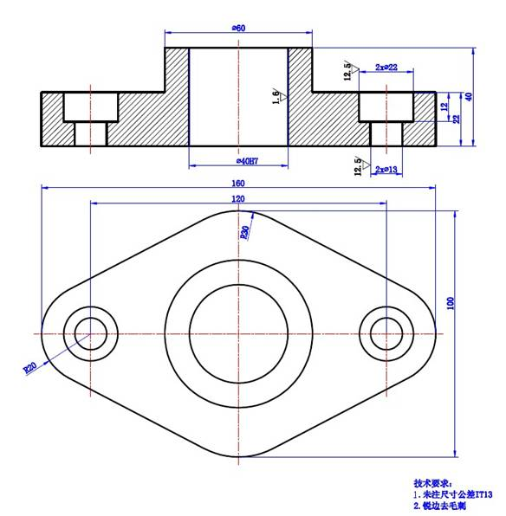

Item 2:
Hose connector for high pressure liquid food processing.

Batch sizes required:
1 off
250 pieces
2500 pieces

Stainless steel: Type 2507

