BTEC Assignment Brief
Qualification |  | Pearson BTEC Level 3 National Extended Diploma in Engineering
Unit number and title |  | Unit 44: Fabrication Manufacturing Processes
Learning aim(s) |  | A: Examine the processes and technology used in sheet metal fabrication that are widely used in industry
Assignment title |  | 1. Sheet Metal Fabrication
Assessor
Issue date
Hand in deadline
Vocational Scenario or Context |  | You are working as a final year apprentice in a sheet metal fabrication engineering company.  As part of your final qualification your supervisor would like you to produce a report that investigates the technology of sheet metal fabrication processes that are used in industry, as he needs some information that may be used in the manufacture of new products. Your supervisor wants you to explore a range of processes.
Task 1 |  | You have been asked to produce a written report that investigates at least two different fabricated products that show the following features  - Types of sheet materials used in fabrication  - Cutting processes  - Forming processes  - Joining processes  - Finishing processes  Your report should include:  - information and/or case studies related to two different products describing the product  - information and/or case studies related to how the product is sustainably manufactured and to the intended accuracy  - an evaluation that compares and contrasts the fabrication processes in order to sustainably manufacture sheet metal components in different batch sizes.
Checklist of evidence required |  | A report focusing on two different sheet metal fabricated products.
Criteria covered by this task:
Unit/Criteria reference | To achieve the criteria you must show that you are able to:
44/A.D1 | Evaluate, using language that is technically correct and of a high standard, the use of contrasting fabrication processes to sustainably manufacture sheet metal components in different batch sizes.
44/A.M1 | Analyse how different fabrication processes are used to sustainably manufacture sheet metal components to the intended accuracy.
44/A.P1 | Explain how different fabrication processes are used to manufacture sheet metal components.
Sources of information to support you with this Assignment |  | Shared drive – Unit 44 Fabrication
Other assessment materials attached to this Assignment Brief

Item 1: Wall mounted bracket

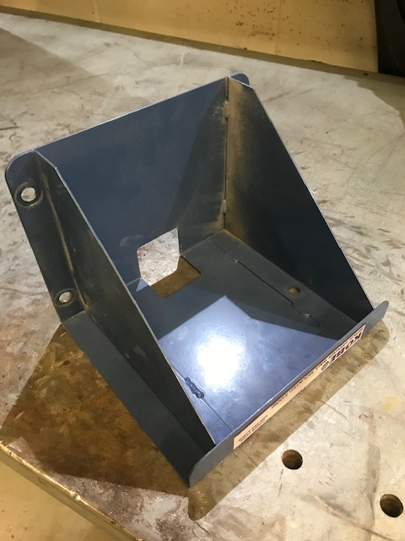 | 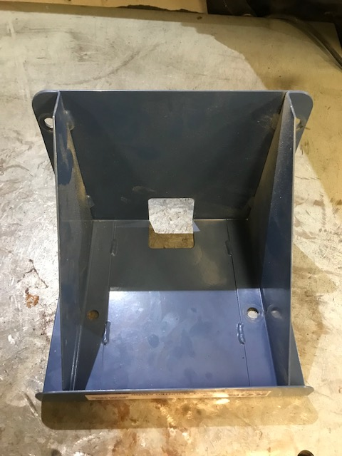 | 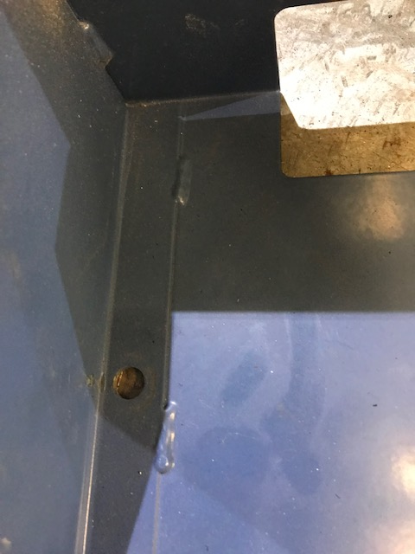
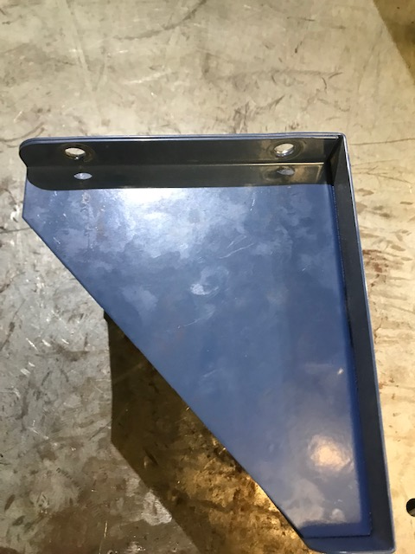 |  | 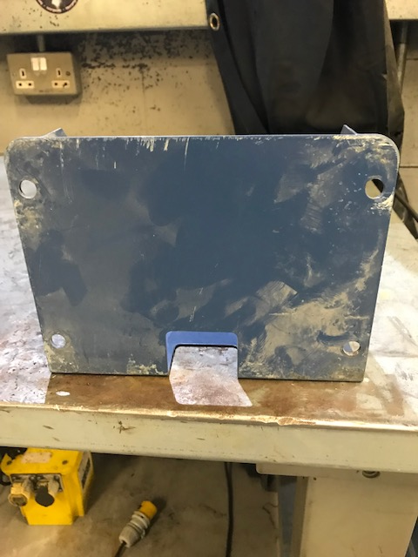

Item 2: Sheet metal open top box

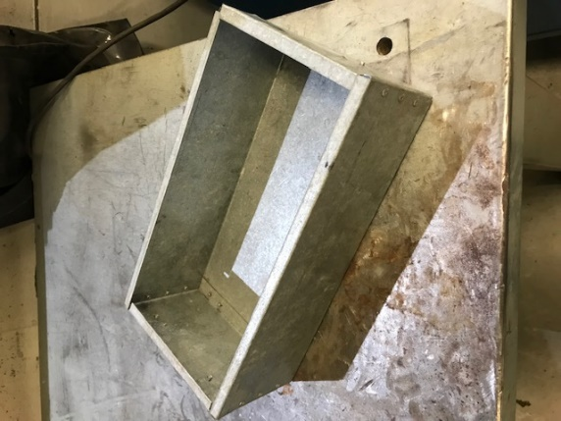 | 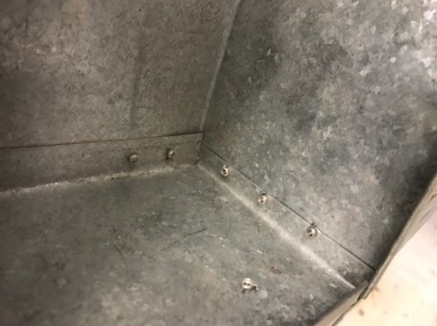 | 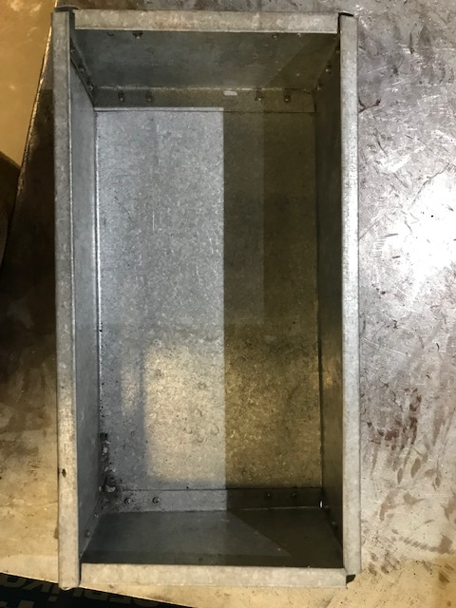
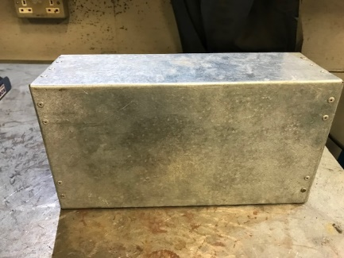 | 